

**YEAR: 7**

**2017**

**SUBJECT: Science**

**TEST: Earth & Space – Predictable Phenomena**

**TIME: 35 minutes**

**QUESTIONS: 16 Multiple Choice (16 marks)**

**5 Short Answer (20 marks)**

**TOTAL MARKS: 36 marks**

**DO NOT WRITE ON OR MARK THIS PAPER**

SHORT ANSWER

There are **sixteen (16)** questions in this section. Answer ALL of them. Mark the correct answer by putting a cross (X) through the corresponding letter on the grid on your answer booklet.

_____________________________________________________________________

1. The moon's gravity causes

1. Tides
2. Phases
3. lunar eclipse
4. solar eclipse

2. Which statement about the Earth's rotation and its revolution is correct?

1. It takes the Earth longer to rotate on its axis than revolve around the sun.
2. It takes the Earth longer revolve around the sun than to rotate on its axis.
3. It takes the Earth longer to rotate around the sun than revolve on its axis.
4. It takes the Earth longer revolve around its axis than to rotate around the sun.

3. A lunar eclipse is when:

1. the moon travels around Earth in an orbit shaped like an oval
2. Earth blocks sunlight from reaching the moon
3. the Moon blocks sunlight from reaching the sun
4. you only see part of the Moon

4. The Earth's axis is tilted at an angle of 23.5°. Imagine if it WASN’T tilted, and was perfectly straight. Which of the following statements would be TRUE?

1. Earth would have the same seasons as it does now
2. The length of a year would change
3. Earth would not have any seasons at all
4. The length of the day would change

5. The length of time it takes the moon to revolve around the Earth once is called a

1. season.
2. month.
3. year.
4. day.

6. As you move further away from Earth, its gravitational force field:

1. gets stronger
2. weakens
3. always stays the same
4. is zero

7. The moon casts a shadow on Earth during a ___________?

1. lunar eclipse
2. new moon
3. phase
4. solar eclipse

8. When the North Pole is tilted TOWARD the Sun, it is?

1. summer in the Northern Hemisphere
2. winter in the Northern Hemisphere
3. daytime in the Southern Hemisphere
4. summer in the Southern hemisphere

9. The picture shows the daylight side of the Earth. Which best describes why the Earth has day and night?

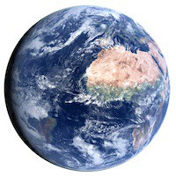

1. The moon rotates on an axis.
2. The Earth rotates on an axis.
3. The moon revolves around the Earth.
4. The Earth revolves around the sun.

10. Which of the following has gravity?

1. the Sun
2. the Earth
3. the Moon
4. all of the above

The diagram below shows a model that was constructed to demonstrate the effect of the Earth’s tilted axis. A torch is used to represent the Sun.

This diagram is used for questions 11 **and** 12.

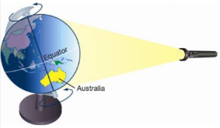

11. In this position, Australia is experiencing:

1. Night
2. Day
3. Winter
4. There is not enough information to decide

12. The part of the Earth that is tilted away from the sun

1. Is in night time
2. Is being shadowed by the moon
3. gets sun 24 hours a day
4. none of the above

13. Which statement best describes the tides experienced on Earth when the Sun, Moon, and Earth are aligned as shown in the diagram?

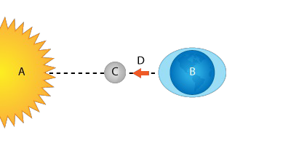

1. maximum high tides, minimum low tides
2. maximum high tides, maximum low tides
3. minimum high tides, maximum low tides
4. minimum high tides, minimum low tide

14. How long does it take for the Earth rotate ONCE on its axis?

1. 1 day
2. 1 year
3. 1 week
4. 1 month

15. What is the name of the force that stops you from floating off into space?

1. Gravity
2. nuclear fusion
3. expansion
4. nuclear fission

16. How long does it take earth to complete one revolution around the sun?

1. 29.5 days
2. 365.25 days
3. 24 hours
4. 72 hours

END OF MULTIPLE CHOICE QUESTIONS

**Year 7**

**2017**

**Test: Earth & Space – Predictable Phenomena**

**ANSWER BOOKLET**

**NAME:**

**FORM:** **DATE:**

Multiple Choice Short Answer Total

**/20**

**/16**

**/15**

**/36**

**/30**

**SECTION ONE:** Multiple choice answers

Cross (X) through the correct answer.

|  |  |  |  |  |
| --- | --- | --- | --- | --- |
| **1** | a | b | c | d |
| **2** | a | b | c | d |
| **3** | a | b | c | d |
| **4** | a | b | c | d |
| **5** | a | b | c | d |
| **6** | a | b | c | d |
| **7** | a | b | c | d |
| **8** | a | b | c | d |
| **9** | a | b | c | d |
| **10** | a | b | c | d |
| **11** | a | b | c | d |
| **12** | a | b | c | d |
| **13** | a | b | c | d |
| **14** | a | b | c | d |
| **15** | a | b | c | d |
| **16** | a | b | c | d |

SHORT ANSWER

This section has **five (5)** questions. Answer ALL of them, in the spaces provided.

17. In the diagram below are two regions labelled A and B.

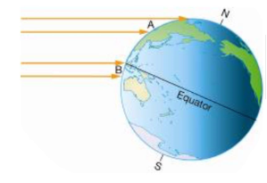

a) Which region would have the hottest climate? (1 mark)

_____________________________________________________________________

b) Explain why. (2 marks)

_______________________________________________________________________________________________________________________________________________________________________________________________________________

18. Explain the difference between the following terms:

Rotation and Revolution (4 marks)

_____________________________________________________________________

19. TRUE or FALSE? (3 marks)

The moon creates light. _______

Tides are controlled by the sun. _______

We can see both sides of the moon from earth. _______

20. On the diagram below, mark and label the points on the Earth’s surface where it is at high tide and low tide. (2 marks)

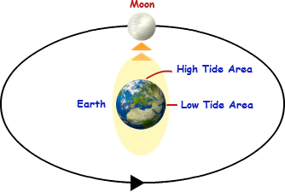

21. Label the phases of the moon shown below.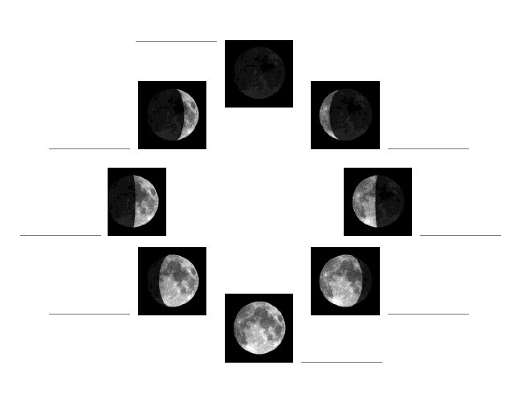

(8 marks)